Poetry Pockets October 3rd Grade Poetry Pockets October 3rd Grade

Five Little Pumpkins
Five little pumpkins sitting on a gate.
The first one said,
“Oh, my it's getting late"
The second one said,
"There are witches in the air."
The third one said,
"But we don't care."
The fourth one said,
"Let's run, let's run!"
The fifth one said,
"Isn't Halloween fun?"
Then Woooooo went the wind
And OUT went the lights.
And five little pumpkins rolled out of sight.

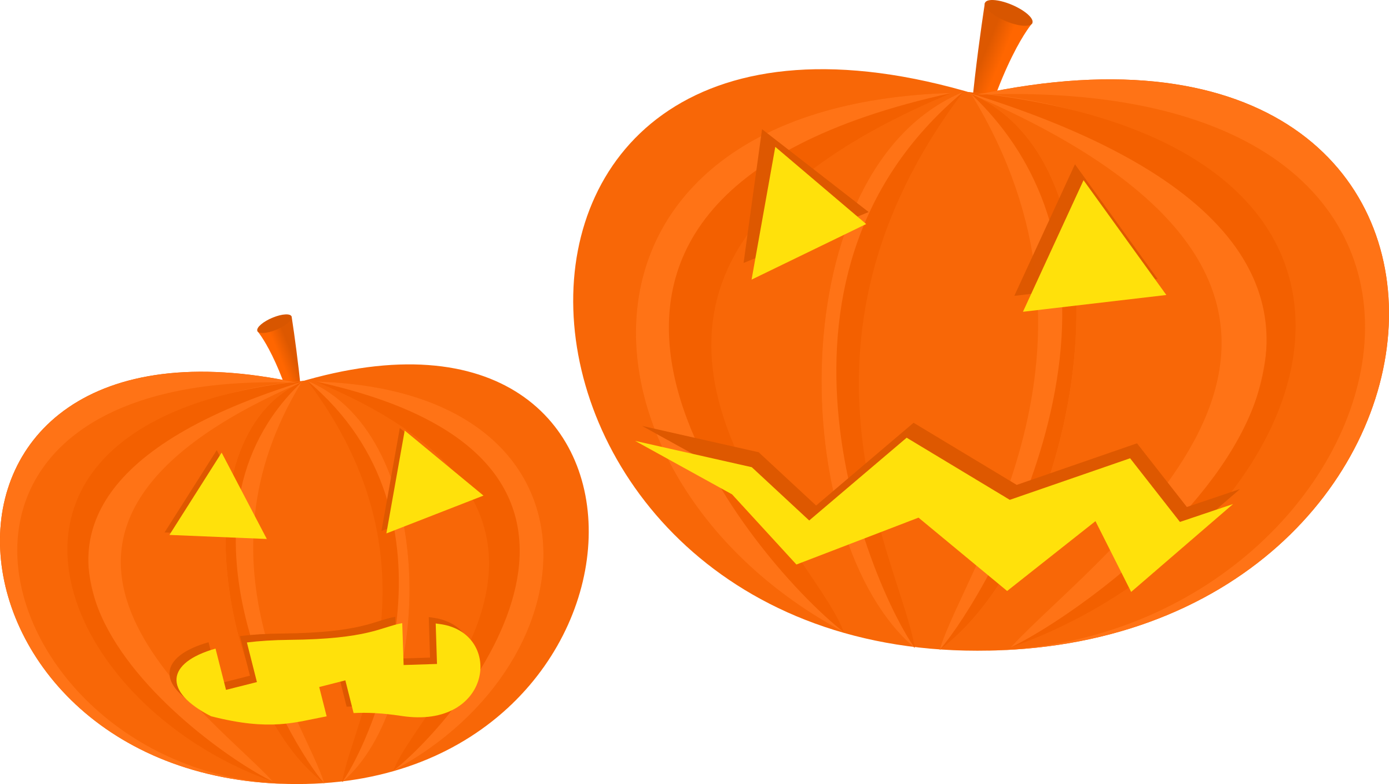

Five Little Pumpkins
Five little pumpkins sitting on a gate.
The first one said,
“Oh, my it's getting late"
The second one said,
"There are witches in the air."
The third one said,
"But we don't care."
The fourth one said,
"Let's run, let's run!"
The fifth one said,
"Isn't Halloween fun?"
Then Woooooo went the wind
And OUT went the lights.
And five little pumpkins rolled out of sight.

