Poetry Pockets November 3rd Grade Poetry Pockets November 3rd Grade

A Thanksgiving Dinner
Take a turkey, stuff it fat,
with some of this and some of that.

Get some turnips, peel them well,
cook a big squash in its shell.

Now potatoes, big and white,
Mash them till they are fluffy and light.

Cranberries, so tart and sweet,
With turkey we must eat.

Now for dessert
we add a pumpkin pie,

Oh my!

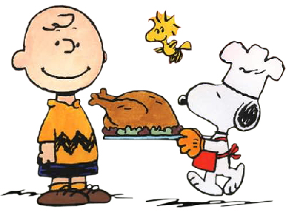

A Thanksgiving Dinner
Take a turkey, stuff it fat,
with some of this and some of that.

Get some turnips, peel them well,
cook a big squash in its shell.

Now potatoes, big and white,
Mash them till they are fluffy and light.

Cranberries, so tart and sweet,
With turkey we must eat.

Now for dessert
we add pumpkin pie.

Oh my!

