Poetry Pockets January 1st Grade Poetry Pockets January 1st Grade
January

January - now is here a fine new start for a whole new year
The snow came down
In the dark of a night
When we awake
The world is white
In January …
When there’s snow
we get our sleds and away
WE GO !!!

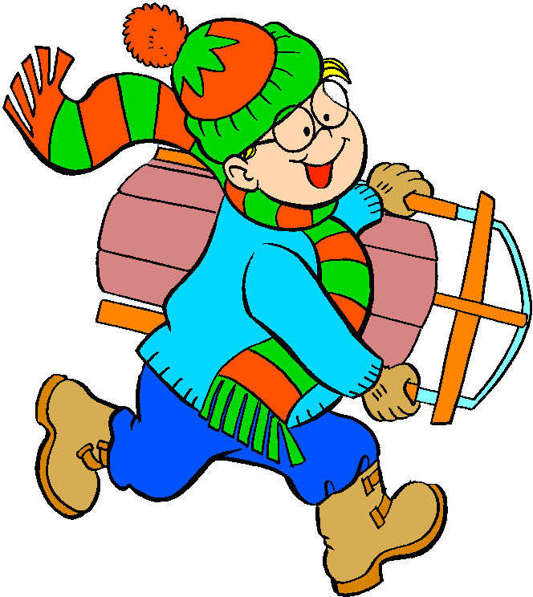
January

January - now is here a fine new start for a whole new year
The snow came down
In the dark of a night
When we awake
The world is white
In January …
When there’s snow
we get our sleds and away
WE GO !!!

